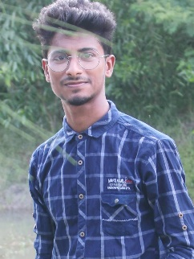

javascript

**M.D kasheam**

**WEB DEVELOPER**

**EXPERIENCE**

**EDUCATION**

**CONTACT**

**SKILLS**

**Senior web developer** 2021-2026

**Web developer**

2020

**Junior web developer**

2020-2021

.

**H.S.C in Dumuriya College**

2019-2020

**S.S.C in Dumuriya School**

2000-2005

**College of Dumuriya**

**Dumuriya School**

01307242240

Skkasheam@gmail.com

nickmichaels.com

Bootrstrap

HTML

CSS